**Project Report**

**Apple _ iphone impact _in _ india**

**1. INTRODUCTION**

**1.1. Overview**

The world has changed as a consequence of the increasing use of smartphones, which have improved communication, connected people, and revolutionized many different businesses.

With its main product, the iPhone, capturing markets around the world, Apple Inc. has emerged as a prominent player among the top smartphone makers.

India, one of the economies with the greatest economic growth, has seen a tremendous increase in smartphone usage, making it an interesting market to study the effects of Apple's iPhone.

In order to shed light on important factors like market penetration, customer preferences, economic ramifications, and societal changes, this research report will perform a data- driven investigation of the impact of the iPhone in India.

This study will offer invaluable insights into the transformative impact of the iPhone on India's technological landscape and the lives of its consumers by using advanced data analytics techniques and analyzing large datasets.

Apple has a special chance to increase its market share and develop a significant presence in India thanks to the country's large population and rising smartphone adoption.

Each new iPhone model unveiling generates excitement and anticipation among Indian buyers. By utilizing the plethora of information

Already accessible, this research aims to go beyond conjecture and anecdotal evidence in order to develop a thorough knowledge of the effects of the iPhone.

1.2. PURPOSE***

**2. PROBLEM DEFINITION & DESIGN THINKS**

**2.1 EMPATHY MAP**

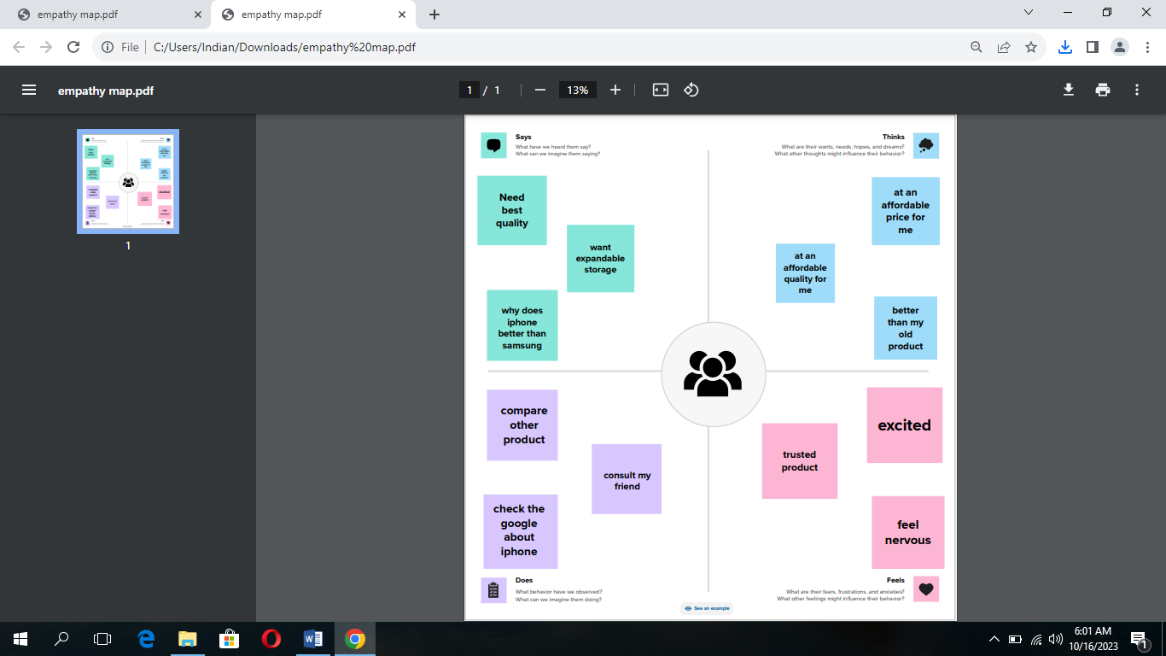

**2.2.ISEATION & BRAINSTROMING MAP**

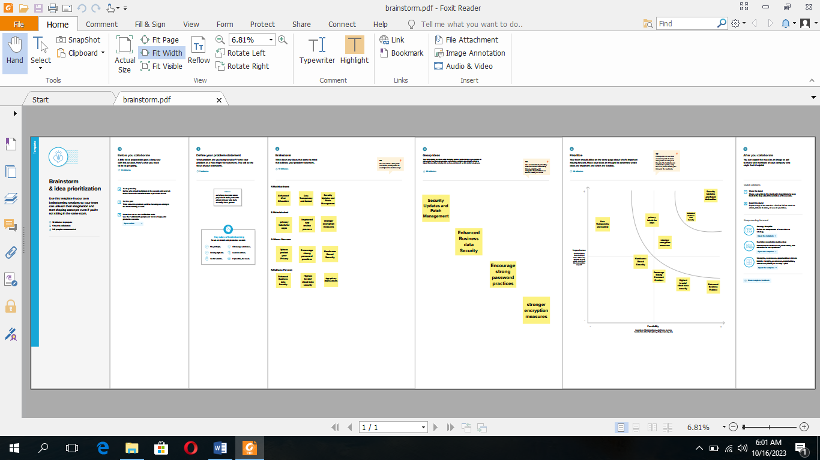

**SHEET 1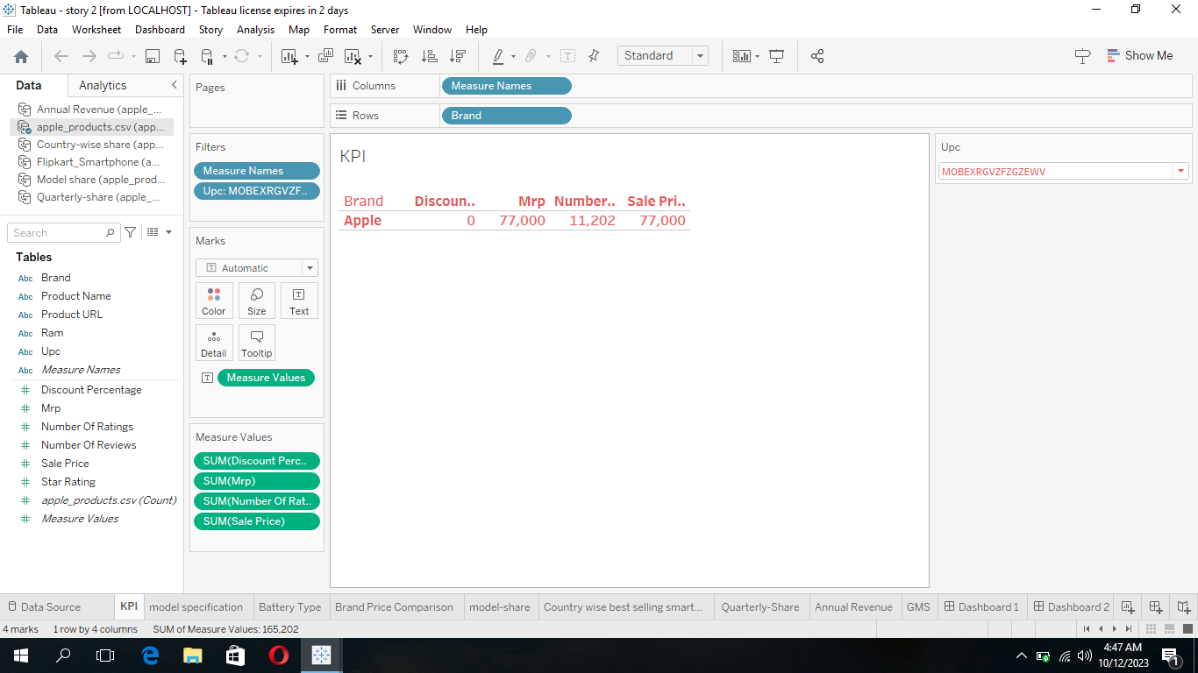SHEET 3**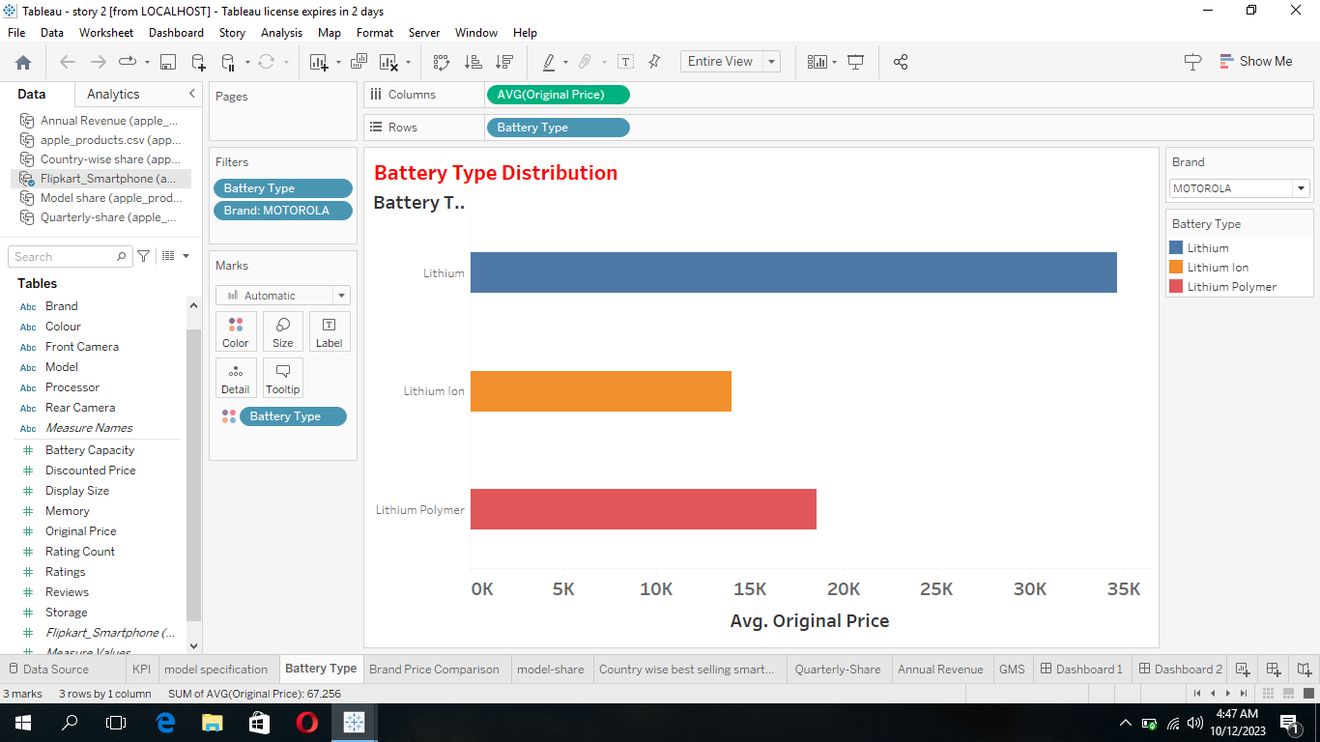

**SHEET 6**

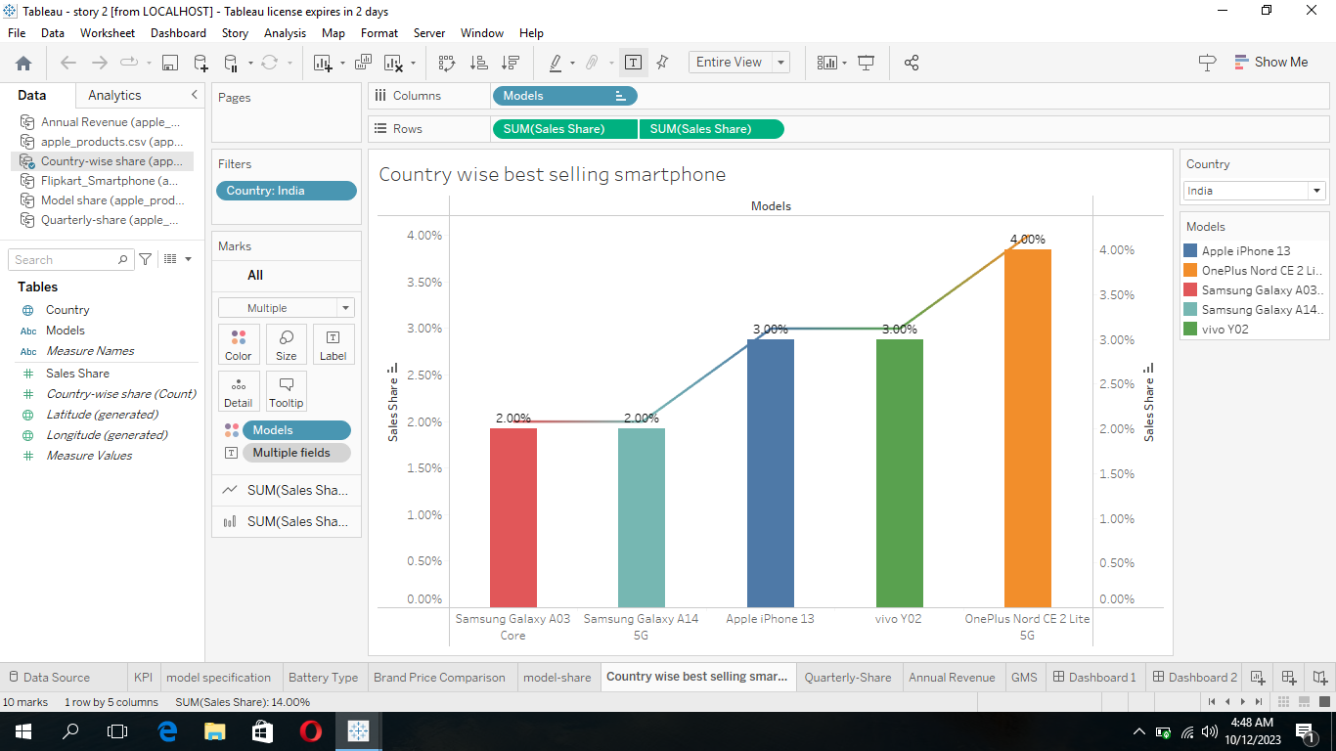

**SHEET 8**

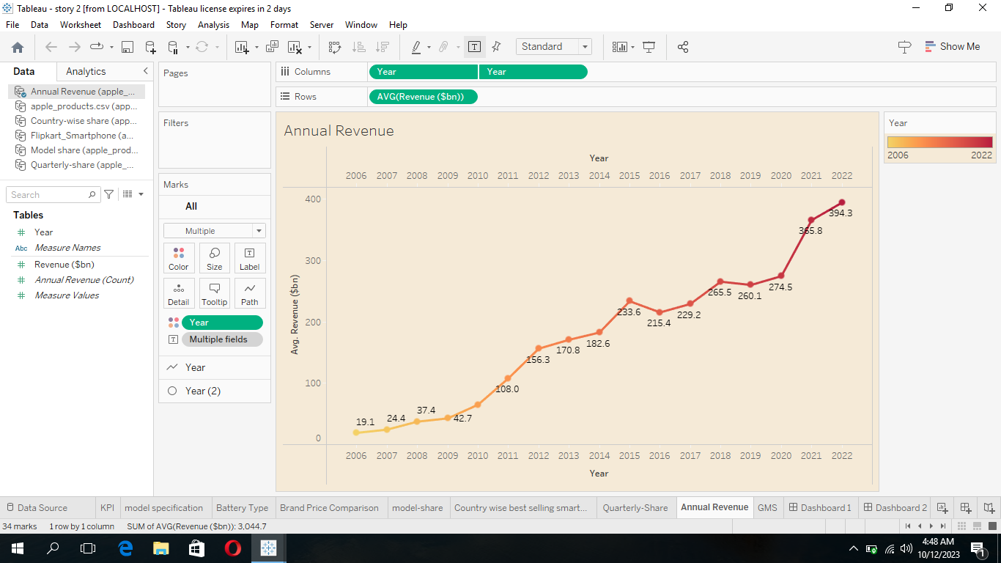

*****DASHBOARD*****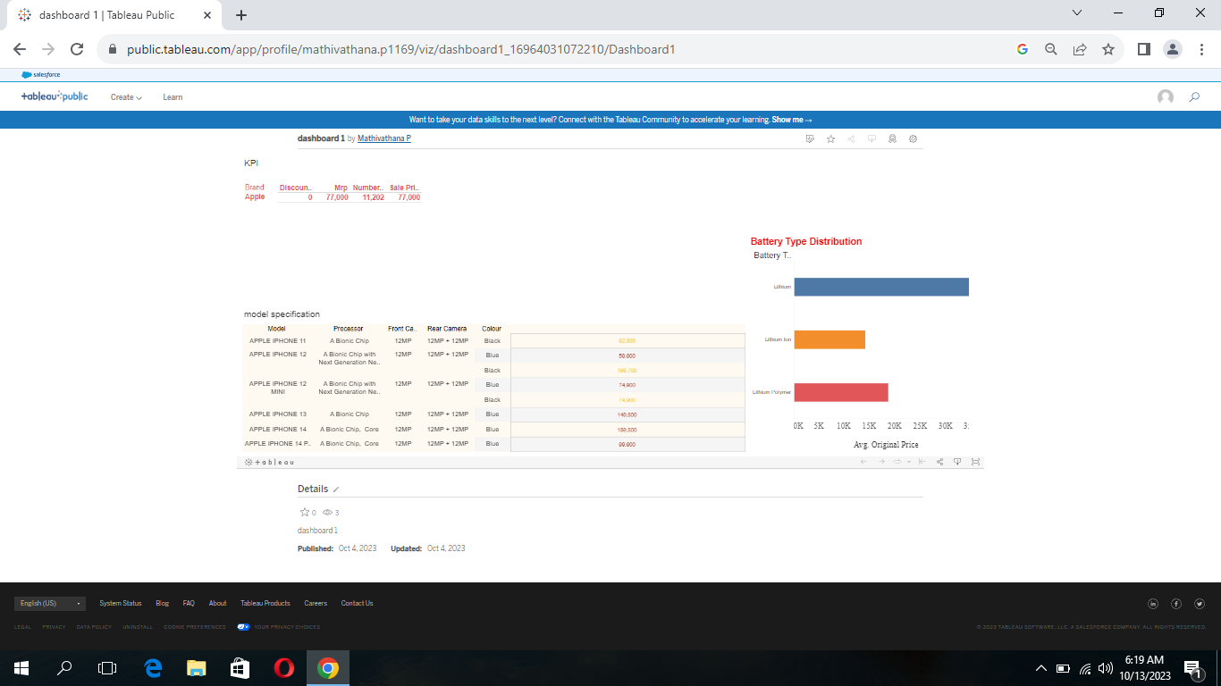

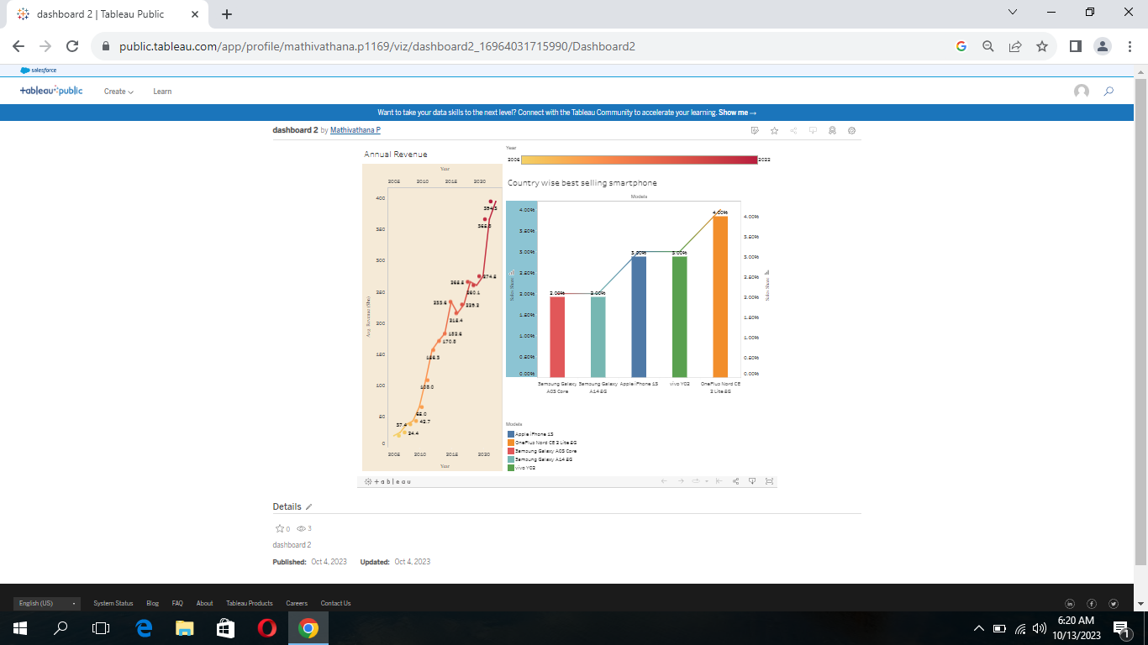

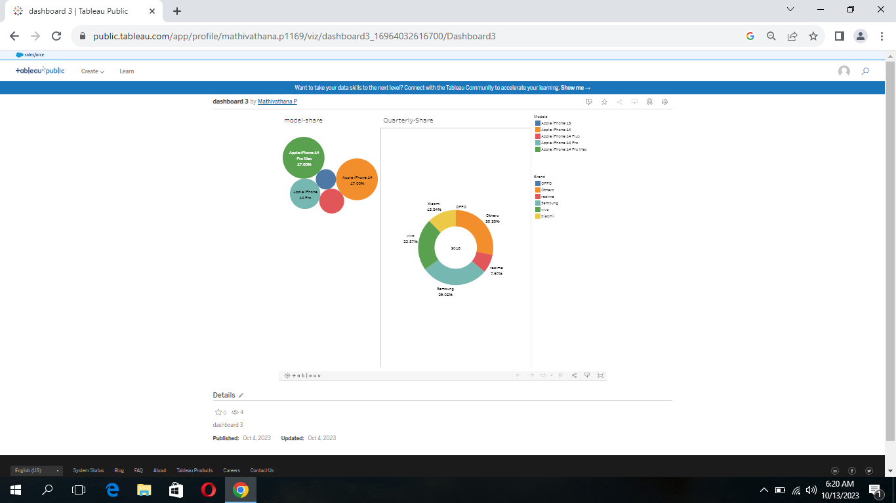

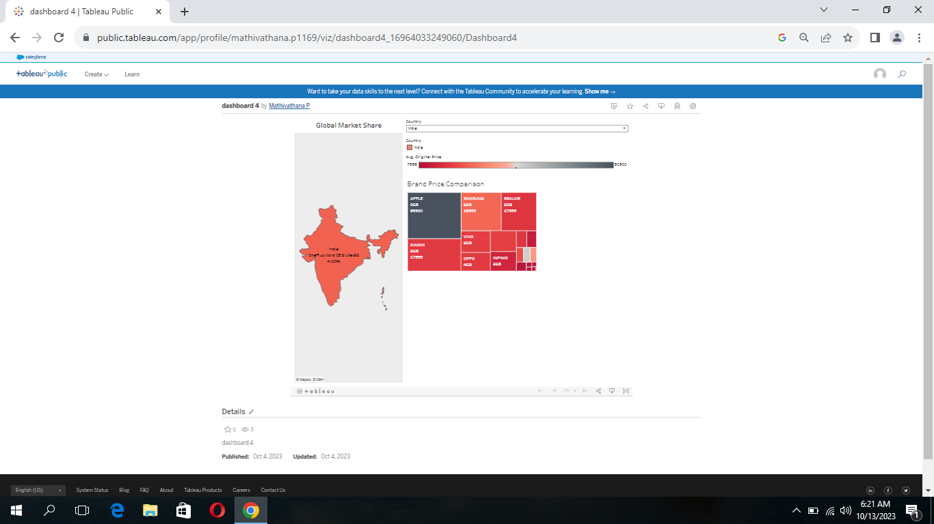

*****STORY*****

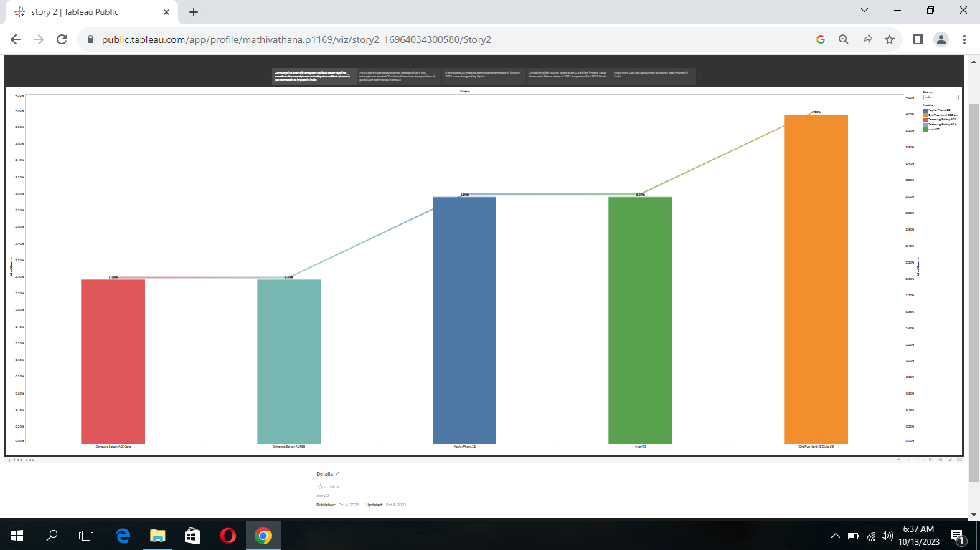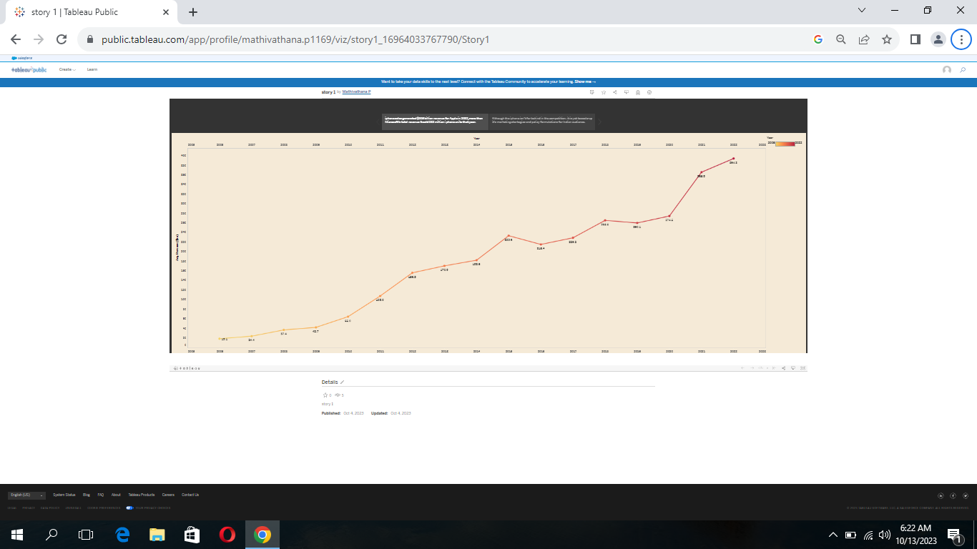

***** TEAM DETAILS *****

TEAM LEADER-P. MATHIVATHANA

MEMBER 1-S. MAHALAKSHMI

MEMBER 2-A.NISMA NASREEN

MEMBER 3-R.RAIHANA PARVEEN

*****ADVANTAGES OF IPHONE*****

1. USER- FRIENDLY INTERFACE

2. HIGH –QUALITY DISPLAY

3. ADVANCED CAMERA

4. APPS ECOSYSTEM

5. SEAMLESS INTEGRATION WITH

OTHER APPLE DEVICES

DISADVANTAGES OF IPHONE

1 .COST

2 .NON REMOVABLE BATTERY

3 .LIMITED CUSTOMIZATION

4. NO EXPANDABLE STORAGE

5. FRAILTY

CONCLUSION

The main conclusion that can be drawn is  we found to be the most interesting about Apple is how they are very innovative and early adapters. Apple is usually the first company to come out with a new product line before anyone else. This is very risky but it seems to be working to Apples advantage. This shows that taking risks can sometimes make or break you and Apple has great potential and has a lot to improve. Currently, Apple is demonstrating negative aspects of TNCs, contributing to international debt crisis through exploitation of workers.

FUTURE SCOPE

The above said in terms of technology is ever changing and evolving.  The mating between hardware and software is optimal. iOS development has a bright future, as iOS is the most preferred platform where most of the Internet of Things (IoT) get complete compatibility and support. Moreover, ultramodern home automation apps are getting developed using iOS only.

APPENDIX

SOURCE DASHBOARD

<https://public.tableau.com/views/dashboard1_16964031072210/Dashboard1?:language=en-US&:display_count=n&:origin=viz_share_link>

SOURCE STORY

<https://public.tableau.com/views/story2_16964034300580/Story2?:language=en-US&:display_count=n&:origin=viz_share_link>